
eMasters Capstone Project Report
Predicting Student Dropout Risk in Online Learning Platforms
Early-Warning Prediction Using the Open University Learning Analytics Dataset (OULAD)

Group 1
Student Name(s):
Adita Tripathi
Kiran Bhan Singh
Mohammed Shujath
Prasad Perecharla

Mentor: Sajid Ansari
Project Supervisor:

Table of Contents
1. Executive Summary .................................................... 3
2. Problem Statement .................................................... 4
3. Objectives and Scope ................................................. 5
4. Literature Review .................................................... 6
5. Dataset Description .................................................. 8
6. Exploratory Data Analysis ............................................ 10
7. Methodology .......................................................... 13
8. Feature Engineering .................................................. 15
9. Model Development and Evaluation Design .............................. 18
10. Baseline Model Comparison ........................................... 20
11. Imbalance and Weighting Experiments ................................. 21
12. Final Untouched-Test Evaluation ..................................... 23
13. Feature Analysis and Ablation ....................................... 25
14. Fairness Analysis ................................................... 27
15. PyTorch Neural Network .............................................. 29
16. Literature and Mentor Replication ................................... 30
17. Limitations and Future Work ......................................... 32
18. Conclusion .......................................................... 33
19. References .......................................................... 34
Appendix A. Feature Inventory ........................................... 35
Appendix B. Experiment Summary .......................................... 36

1. Executive Summary
This project develops an early-warning machine-learning system for predicting whether a student enrolled in an online learning module will ultimately withdraw. The study uses the Open University Learning Analytics Dataset (OULAD), which combines student demographics, course information, assessments, registration records, and virtual-learning-environment (VLE) interactions.
A key design requirement is that the prediction must occur early enough to support an intervention. The project therefore uses a course-relative checkpoint at 25% of each module presentation and excludes information that would not be available at that point.
The final modeling dataset contains 32,593 student-course enrollments and 54 predictors before categorical encoding: 46 numeric and 8 categorical. The positive class is Withdrawn and Pass, Fail, and Distinction form the negative class.
The confirmed candidate is HistGradientBoosting with withdrawal weight 3.0. It was selected using training and evaluation partitions and then refitted on the combined development data before one final score on the untouched test partition.
Metric | Final test
Accuracy | 0.816
Balanced Accuracy | 0.804
ROC-AUC | 0.874
PR-AUC | 0.797
Withdrawal Precision | 0.667
Withdrawal Recall | 0.775
Withdrawal F1 | 0.717

2. Problem Statement
Online learning environments generate extensive behavioral and academic data, but the useful question is not simply whether withdrawal can be predicted after the fact. The question is whether risk can be identified early enough for support to be useful.
The target is final_result == Withdrawn. Pass, Fail, and Distinction are mapped to zero. The observation boundary is 25% of each course presentation.
False negatives are particularly important because a missed withdrawal represents a missed opportunity for intervention. False positives are also important because support teams have limited capacity.
- Target: Withdrawn = 1; all other outcomes = 0.
- Prediction timing: 25% of course presentation.
- Primary metrics: PR-AUC, ROC-AUC, recall, precision, F1, balanced accuracy.
- Operational concern: false negatives and alert volume.
- Predictive association is not interpreted as causation.

3. Objectives and Scope
The project is designed as a leakage-controlled supervised-learning study. Its purpose is to establish a credible early-warning baseline, understand the information contained in early student behavior, and document the trade-offs involved in model selection and fairness.
- Construct a reproducible OULAD modeling dataset.
- Define and enforce the 25% information boundary.
- Engineer early VLE, assessment, registration, profile, and course features.
- Compare baseline classification algorithms.
- Evaluate class-weighting and data-augmentation strategies.
- Freeze a candidate without using the test partition for selection.
- Perform feature and feature-group analysis.
- Audit subgroup outcomes and test fairness-aware learning.
- Compare a tabular neural network.
- Compare selected literature and mentor implementations under like-for-like conditions.

4. Literature Review
The literature review shows that reported dropout performance depends strongly on the definition of dropout, the observation window, the feature construction, the split design, and the presence or absence of leakage.
The Jha-style reconstruction is relevant because it uses OULAD VLE, assessment, and demographic aggregates. However, its whole-course result is not directly comparable with the present 25% early-warning problem.
The Khorasani OULAD fairness implementation is the closest target match among the repositories examined. The notebooks identify potential student-overlap, VLE aggregation, and outcome-derived-variable issues in variants of the approach.
Other reviewed studies use different targets such as Fail + Withdrawn versus Pass + Distinction or use sequence models with ordered activity. Such results are useful for research direction but cannot replace the current benchmark.
Approach | Target | Comparable? | Lesson
Jha-style | Withdrawn vs Others | 25% variant only | Whole-course score is not an early-warning score
Khorasani | Withdrawn vs Others | Corrected variants | Leakage and student overlap matter
Different-target studies | Varies | No | Target definition changes the task
Sequence models | Varies | Not directly | Temporal inputs may capture additional signal

5. Dataset Description
OULAD is a relational dataset rather than a single flat modeling file. The final row represents one student in one module presentation. Assessment and VLE tables contain multiple records per student-course pair and are aggregated.
The main modeling key is code_module + code_presentation + id_student. Course-level reference information is joined through code_module + code_presentation.
Table | Rows | Columns | Role
assessments.csv | 206 | 6 | Assessment definitions
courses.csv | 22 | 3 | Course/presentation context
studentAssessment.csv | 173,912 | 5 | Scores and submissions
studentInfo.csv | 32,593 | 12 | Student profile and final outcome
studentRegistration.csv | 32,593 | 5 | Registration timing
vle.csv | 6,364 | 6 | VLE site metadata
studentVle.csv | Large | 6 used | Student clickstream

5.1 Data Quality and Missingness
The source tables contain missing values in several fields. The notebooks distinguish structural missingness from event absence and from variables that require training-only imputation.
Assessments contain 11 missing dates; studentAssessment contains 173 missing scores; studentInfo contains 1,111 missing IMD values; studentRegistration contains substantial missing unregistration values and 45 missing registration dates; VLE metadata contains missing week_from and week_to values.
date_unregistration is not imputed for modeling because it is excluded completely due to leakage.
Table | Missing cells | Important missing field
assessments | 11 | date
courses | 0 | None
studentAssessment | 173 | score
studentInfo | 1,111 | imd_band
studentRegistration | 22,566 | date_unregistration/date_registration
vle | 10,486 | week_from/week_to

6. Exploratory Data Analysis
The binary target contains 22,437 non-withdrawn and 10,156 withdrawn enrollments, producing a 31.16% withdrawal rate.
Withdrawal rates vary materially across modules and presentations. CCC has approximately 44.5% withdrawal while GGG has approximately 11.5%.
Observed profile differences include higher withdrawal rates among students marked as disabled and among lower education groups. These differences are retained as descriptive evidence and for fairness auditing, not causal conclusions.
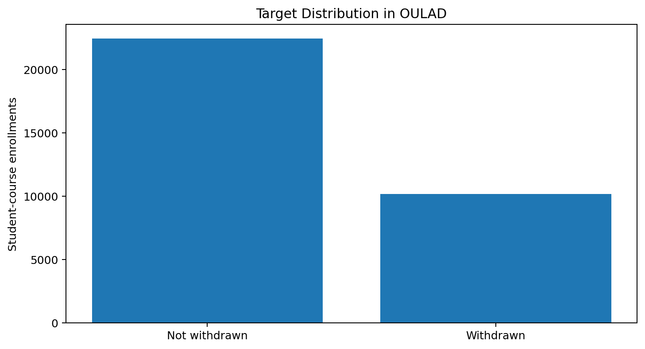
Figure 1. Binary target distribution.
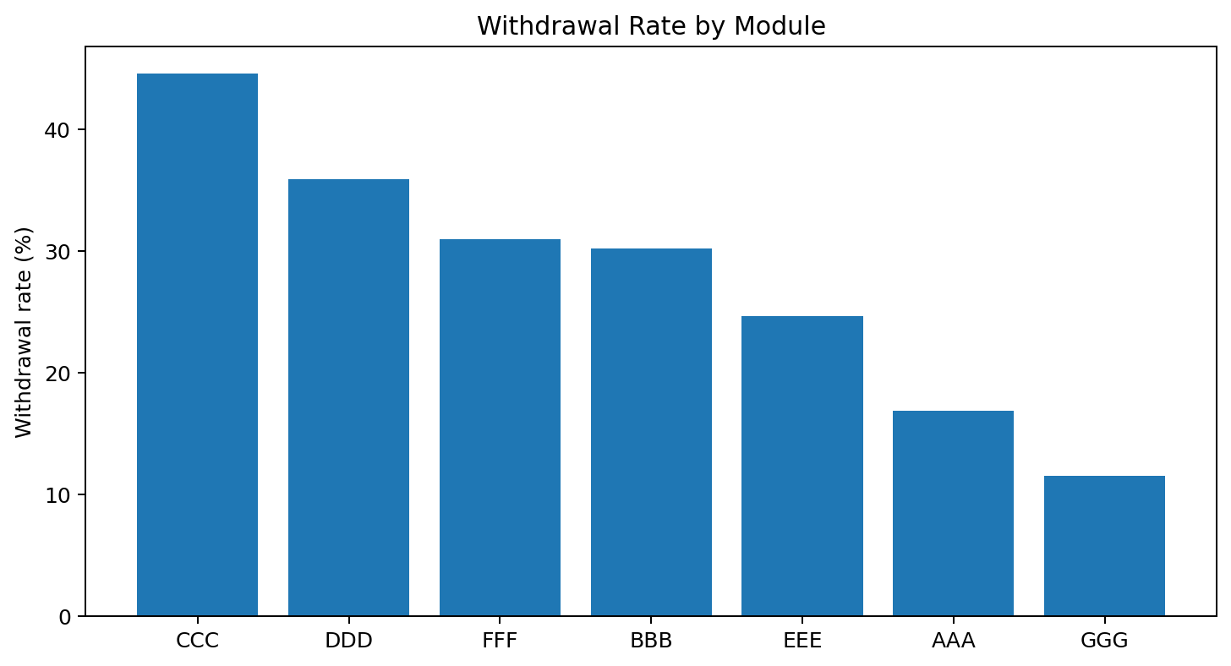
Figure 2. Withdrawal rate by module.

6.1 EDA: Course and Presentation Patterns
Course context is predictive because withdrawal prevalence differs by module and presentation. The four presentation periods show rates of approximately 26.8%, 28.8%, 33.5%, and 34.0%.
Course duration itself has little simple linear correlation with the target, but the course duration is needed to calculate the operational checkpoint.
The EDA therefore supports including course context while keeping the intervention point explicitly course-relative.
Presentation | Records | Withdrawal rate
2013J | 8,845 | 26.78%
2013B | 4,684 | 28.78%
2014B | 7,804 | 33.48%
2014J | 11,260 | 33.98%

6.2 EDA: Demographic and Student Profile
Gender differences are relatively small in the raw data: approximately 31.72% for males and 30.48% for females.
Students aged 0–35 have a withdrawal rate of approximately 32.17%, compared with 28.85% for ages 35–55 and 25.00% for the small 55+ group.
Disability status shows a larger descriptive difference, with approximately 39.35% withdrawal for students marked Yes and 30.28% for students marked No.
Highest education also varies, with the No Formal Qualifications group showing approximately 42.94% withdrawal and Post Graduate Qualification approximately 23.64%.
Attribute | Group | Withdrawal rate
Gender | Male | 31.72%
Gender | Female | 30.48%
Age | 0–35 | 32.17%
Age | 35–55 | 28.85%
Disability | Yes | 39.35%
Disability | No | 30.28%

6.3 EDA: Numeric Associations
Among the original static numeric variables, studied_credits has the strongest linear correlation with withdrawal at approximately 0.191. Number of previous attempts has a much smaller positive correlation of approximately 0.033.
Later feature engineering produces much stronger associations for early assessment missingness and VLE recency. This illustrates why raw EDA and feature engineering answer different questions.
Pearson correlation is used only as a screening tool. It does not capture categorical structure, nonlinear relationships, interactions, or causal effects.
Variable | Correlation
studied_credits | 0.191
num_of_prev_attempts | 0.033
module_presentation_length | -0.006
checkpoint_day | -0.008

7. Methodology
The methodology is organized around a strict leakage-safe sequence. Data are loaded and validated, the target is defined, the checkpoint is calculated, early features are constructed, the modeling table is formed, and students are grouped across train/evaluation/test partitions.
Model selection occurs only using training and evaluation data. The test partition is held back for a single final score.
- Load relational OULAD tables.
- Define target and 25% checkpoint.
- Engineer registration, VLE, and assessment features.
- Exclude leakage and identifier-only variables.
- Create student-grouped 70/15/15 partitions.
- Fit preprocessing on training data only.
- Compare candidate model families.
- Select weighting and model using evaluation data.
- Refit frozen candidate on development data.
- Score untouched test partition once.

7.1 Leakage Control
Leakage control is central to the credibility of the result. The model must not see the final outcome indirectly or use information that would only become available after the intervention point.
date_unregistration is explicitly excluded because it can reveal that withdrawal has occurred. Post-checkpoint VLE and assessment records are excluded. id_student is retained only as a grouping key and is not a predictor.
Early non-submission is valid when the assessment was due by the checkpoint. In contrast, knowing that an assessment was never submitted during the whole course is future information and is invalid for the early-warning task.
Evidence | Decision | Reason
final_result | Exclude | Direct target
date_unregistration | Exclude | Outcome-revealing
Post-checkpoint VLE | Exclude | Future information
Post-checkpoint assessments | Exclude | Future information
Early missing assessment | Include | Valid checkpoint evidence
Early VLE inactivity | Include | Valid checkpoint evidence

7.2 Grouped Train–Evaluation–Test Split
Students with multiple enrollments must not be split across partitions. The notebooks implement a 70/15/15 design while preserving student grouping.
The resulting partitions contain 22,833 training rows, 4,864 evaluation rows, and 4,896 test rows. Student overlap between partitions is zero.
The evaluation set is used for model selection and the test set is reserved for the final report.
Partition | Rows | Share | Purpose
Training | 22,833 | 70.1% | Model fitting
Evaluation | 4,864 | 14.9% | Selection
Test | 4,896 | 15.0% | Final score

8. Feature Engineering
The feature design contains five major groups: student profile, registration timing, course context, early VLE engagement, and early assessment behavior.
Profile variables include demographics, prior attempts, credits, disability, education, region, age, and IMD band. Registration variables describe how early the learner registered. Course variables describe module/presentation context.
Behavioral variables are computed only from the early window.
Group | Representative features
Student profile | gender, region, education, age, IMD, disability, prior attempts, studied credits
Registration | registration day, missing flag, before/after start
Course | module, presentation, duration, checkpoint
VLE | clicks, events, active days, distinct sites, recency, activity types
Assessment | due/submitted/missing, scores, delay, late count, banked count

8.1 VLE Feature Engineering
The VLE table is processed in chunks. Each event is joined to its student-course checkpoint and retained only when date <= checkpoint_day.
Generated features include total_clicks_25pct, vle_events_25pct, active_days_25pct, distinct_sites_25pct, last_activity_day_25pct, days_since_last_activity_at_checkpoint, and activity-type click aggregates.
The top activity types include resource, subpage, oucontent, url, forumng, quiz, page, oucollaborate, questionnaire, ouwiki, dataplus, and externalquiz. Other activity types are aggregated.
VLE feature | Interpretation
total_clicks_25pct | Activity volume
vle_events_25pct | Number of observed VLE events
active_days_25pct | Consistency of engagement
distinct_sites_25pct | Breadth of resources accessed
last_activity_day_25pct | Most recent activity
days_since_last_activity_at_checkpoint | Inactivity/recency
no_early_vle_activity_flag | Explicit no-activity signal

8.2 Assessment Feature Engineering
Only assessments due by the checkpoint are considered. Only submissions recorded by the checkpoint are aggregated.
Students with an early assessment due but no submission contribute to early_assessments_missing_count. This is an important behavioral signal because it represents non-completion observed before the intervention point.
Feature | Meaning
early_assessments_due_count | Assessments due by checkpoint
early_assessments_submitted_count | Assessments submitted by checkpoint
early_assessments_missing_count | Due minus submitted
mean_early_score | Mean observed score
weighted_early_score | Score weighted by assessment weight
average_submission_delay | Average delay
late_submission_count | Number of late submissions
banked_assessment_count | Banked early assessments

8.3 Final Modeling Dataset and Preprocessing
The final modeling dataset has 32,593 rows and 56 columns before separating target and identifier. There are 46 numeric and 8 categorical predictors.
Count-like event features are zero-filled when their absence means no event was observed. Score and timing features retain missingness indicators and are imputed within the training pipeline.
The encoded feature matrix contains 93 features. PCA would require 39 components to retain 95% of training variance, but PCA is not used for the tree-based candidates because it reduces feature interpretability.
Item | Value
Rows | 32,593
Numeric predictors | 46
Categorical predictors | 8
Encoded features | 93
PCA components for 95% variance | 39
PCA decision | Not used

9. Model Development and Evaluation Design
Candidate models are Logistic Regression, Random Forest, HistGradientBoosting, XGBoost, and later a PyTorch MLP.
Logistic Regression provides an interpretable linear baseline. Random Forest provides a nonlinear bagging baseline. Gradient boosting models are expected to perform strongly on mixed tabular data.
Metric | Project interpretation
Accuracy | Overall correctness
Balanced accuracy | Equal importance to both classes
Precision | Reliability of alerts
Recall | Fraction of withdrawals detected
F1 | Balance between precision and recall
ROC-AUC | Ranking across thresholds
PR-AUC | Withdrawal-focused ranking
FN | Missed withdrawals
FP | Unnecessary alerts

10. Baseline Model Comparison
The initial four-model evaluation shows XGBoost and HistGradientBoosting as the strongest candidates. XGBoost has slightly higher ROC-AUC and recall, while HGB becomes the preferred candidate after the evaluation-only weight sensitivity experiment.
Model | Accuracy | Balanced Acc. | ROC-AUC | PR-AUC | Precision | Recall | F1
Logistic Regression | 0.825 | 0.807 | 0.874 | 0.802 | 0.710 | 0.757 | 0.733
Random Forest | 0.837 | 0.788 | 0.883 | 0.819 | 0.797 | 0.652 | 0.717
HistGradientBoosting | 0.832 | 0.813 | 0.883 | 0.824 | 0.724 | 0.759 | 0.741
XGBoost | 0.833 | 0.815 | 0.885 | 0.824 | 0.724 | 0.764 | 0.744

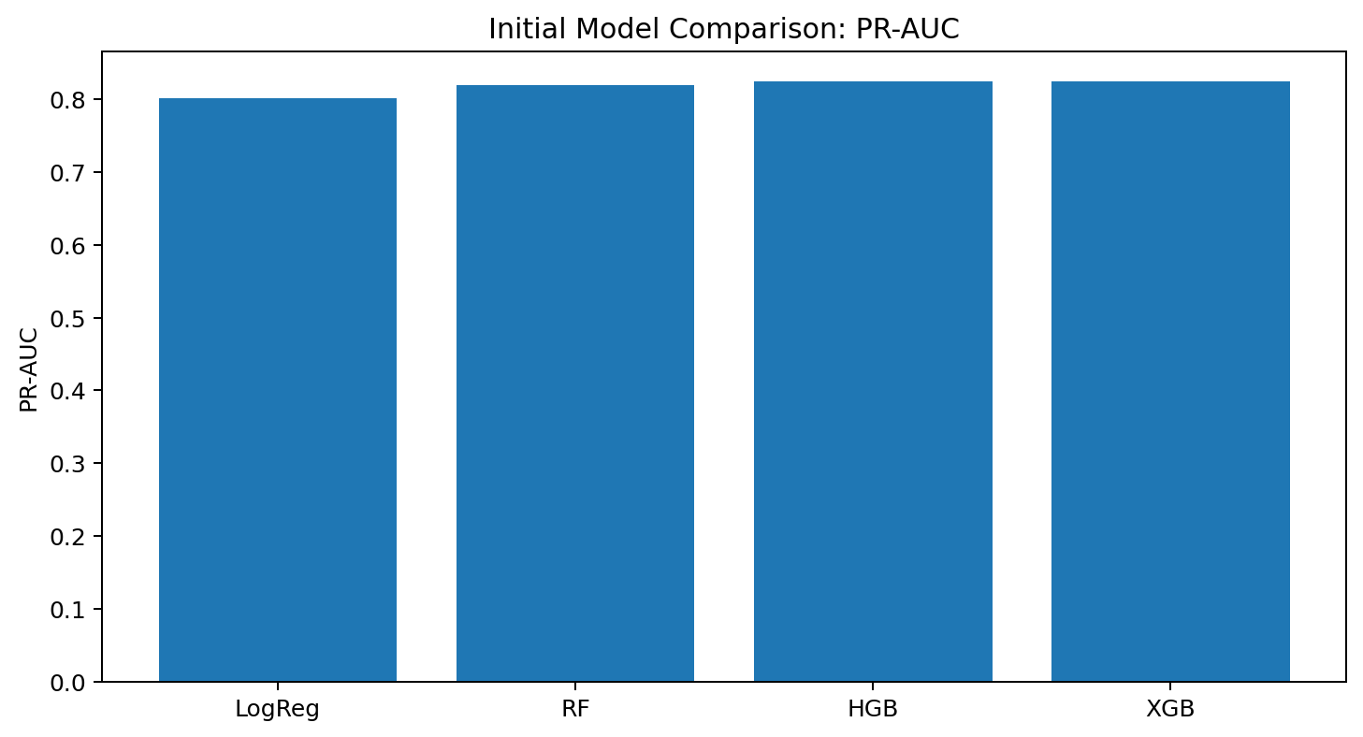
Figure 3. Initial PR-AUC comparison.

11. Imbalance and Weighting Experiments
Withdrawal is a moderate minority class. The project compares balanced sample weighting, Random Oversampling, and SMOTENC while leaving the test data unchanged.
Balanced sample weighting retains all real observations and changes their relative training importance. Random Oversampling duplicates complete withdrawal observations. SMOTENC creates synthetic observations while preserving categorical treatment.
The tested augmentation methods do not improve both recall and F1, so weighting remains preferred.
Strategy | Precision | Recall | F1 | ROC-AUC | PR-AUC | FP | FN
Balanced sample weights | 0.724 | 0.759 | 0.741 | 0.883 | 0.824 | 445 | 371
Random Oversampling | 0.731 | 0.744 | 0.737 | 0.880 | 0.819 | 421 | 395
SMOTENC | 0.784 | 0.683 | 0.730 | 0.880 | 0.819 | 290 | 488

11.1 Withdrawal Weight Sensitivity
The notebooks test relative withdrawal weights of 1.0, 1.5, 2.0, the training-derived balanced ratio, 3.0, and 4.0. The comparison is made on evaluation data only.
HistGradientBoosting with weight 3.0 achieves the preferred recall/F1 trade-off and is frozen before the test partition is opened.
Candidate | Purpose
1.0 | No extra withdrawal emphasis
1.5 | Moderate emphasis
2.0 | Higher emphasis
~2.197 | Training-derived balanced ratio
3.0 | Selected HGB operating weight
4.0 | Higher emphasis; not selected

12. Final Untouched-Test Evaluation
The frozen HGB model is refitted on combined training and evaluation data. The test partition is then scored once. The result is the headline performance reported for the project.
The final confusion matrix contains 2,851 true negatives, 570 false positives, 332 false negatives, and 1,143 true positives.
Actual / Predicted | Not Withdrawn | Withdrawn
Not Withdrawn | 2,851 | 570
Withdrawn | 332 | 1,143

12.1 Final Metrics and Operational Meaning
Accuracy is 0.816, balanced accuracy 0.804, ROC-AUC 0.874, PR-AUC 0.797, precision 0.667, recall 0.775, and F1 0.717.
The test majority-class accuracy baseline is approximately 0.699. Random ROC-AUC is 0.50 and random PR-AUC is approximately the withdrawal prevalence, around 0.301.
The model therefore provides meaningful ranking and withdrawal-detection signal beyond majority prediction, although there is still a substantial missed-withdrawal population.
Metric | Value
Accuracy | 0.816
Balanced Accuracy | 0.804
ROC-AUC | 0.874
PR-AUC | 0.797
Withdrawal Precision | 0.667
Withdrawal Recall | 0.775
Withdrawal F1 | 0.717

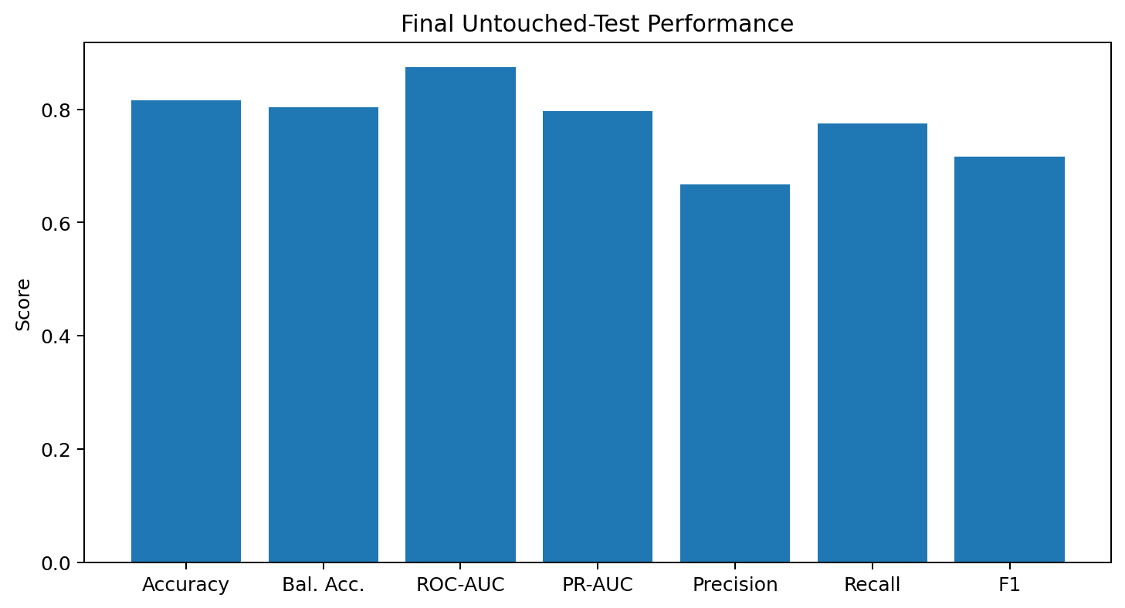
Figure 4. Final untouched-test performance.

13. Feature Analysis and Ablation
The one-feature-at-a-time experiment trains the same HGB framework separately on each predictor. This answers how much standalone withdrawal signal a feature contains. It is not conventional feature importance and does not establish causation.
active_days_25pct has the highest standalone PR-AUC at 0.653. early_assessments_missing_count has PR-AUC 0.642 and standalone F1 0.686.
Rank | Standalone feature | PR-AUC | Recall | F1 | Interpretation
1 | active_days_25pct | 0.653 | 0.729 | 0.584 | Breadth/consistency of early engagement
2 | early_assessments_missing_count | 0.642 | 0.756 | 0.686 | Early non-completion is a strong risk signal
3 | clicks_other_activity_25pct | 0.641 | 0.744 | 0.566 | Captures additional early activity
4 | vle_events_25pct | 0.639 | 0.729 | 0.569 | Overall early platform engagement
5 | total_clicks_25pct | 0.639 | 0.719 | 0.565 | Volume of early activity
6 | last_activity_day_25pct | 0.631 | 0.727 | 0.647 | Recency of engagement
7 | days_since_last_activity_at_checkpoint | 0.631 | 0.710 | 0.654 | Inactivity near intervention point
8 | mean_early_score | 0.623 | 0.746 | 0.639 | Early academic performance

13.1 Feature-Group Ablation
Early assessment behavior and early VLE engagement provide the largest unique information. Removing them from the full model reduces PR-AUC by approximately 0.028 and 0.031 respectively.
Student profile and course context contribute smaller incremental ranking information after behavioral evidence is available. Registration timing adds very little unique ranking information in the tested feature set.
Feature group | Features | Only-group PR-AUC | PR-AUC lost if removed | Recall lost if removed
Early VLE engagement | 20 | 0.743 | 0.031 | 0.019
Early assessment behavior | 18 | 0.758 | 0.028 | 0.056
Student profile | 8 | 0.453 | 0.013 | -0.003
Course context | 4 | 0.383 | 0.009 | 0.003
Registration timing | 4 | 0.375 | 0.001 | 0.000

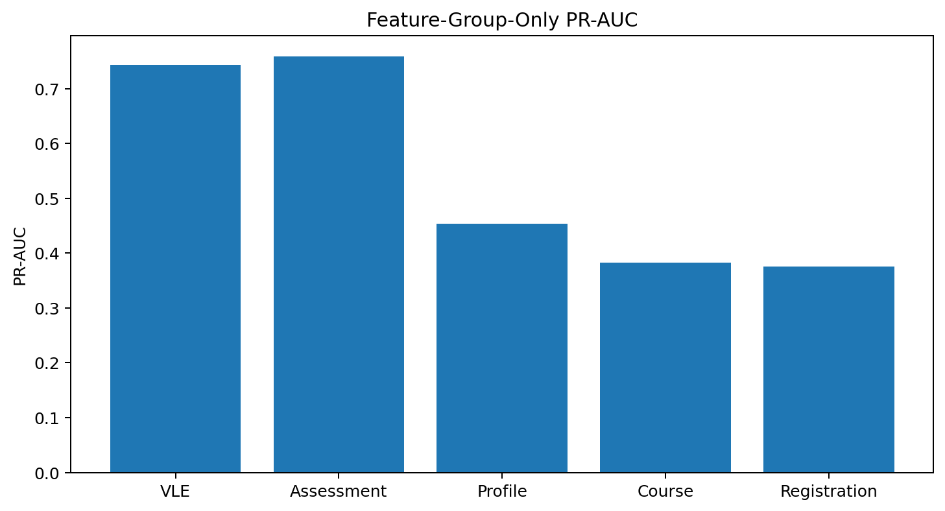
Figure 5. Feature-group-only PR-AUC.

14. Fairness Analysis
Fairness is examined because a support model should not systematically miss students from particular groups. The notebook evaluates selection rate, TPR/recall, FNR, FPR, and precision gaps.
Gender shows very small observed gaps in the MLP audit. Larger gaps occur for highest education and IMD band. The 55+ age group is very small, with only 34 evaluation observations, so its gap estimates are uncertain.
Attribute | Groups | Smallest n | Selection-rate gap | TPR/Recall gap | FPR gap | Precision gap
age_band | 3 | 34 | 0.026 | 0.237 | 0.023 | 0.054
disability | 2 | 471 | 0.163 | 0.107 | 0.115 | 0.029
gender | 2 | 2172 | 0.001 | 0.035 | 0.006 | 0.009
gender × disability | 4 | 233 | 0.226 | 0.127 | 0.183 | 0.056
highest_education | 5 | 48 | 0.441 | 0.457 | 0.225 | 0.100
imd_band | 11 | 151 | 0.259 | 0.264 | 0.175 | 0.218

DPD is the difference between the highest and lowest eligible-group alert rates. EOD is the difference between the highest and lowest eligible-group withdrawal recall (TPR). Groups contribute only when they contain at least 30 withdrawals and 30 non-withdrawals.
Audit attribute | Eligible groups | Logistic Regression  DPD / EOD | Histogram Boosting  DPD / EOD | Neural Network  DPD / EOD
Gender | 2 | 0.006 / 0.016 | 0.030 / 0.010 | 0.014 / 0.006
Disability | 2 | 0.134 / 0.081 | 0.136 / 0.068 | 0.129 / 0.069
IMD band | 10 | 0.160 / 0.171 | 0.186 / 0.104 | 0.172 / 0.133
Gender x disability | 4 | 0.179 / 0.119 | 0.225 / 0.148 | 0.197 / 0.134
Disability x deprivation | 4 | 0.228 / 0.106 | 0.238 / 0.101 | 0.218 / 0.092

Gender differences are small across all three models (DPD 0.006-0.030; EOD 0.006-0.016). Disability differences are more noticeable, while the largest alert-rate gaps occur for IMD and intersectional groups, reaching 0.238 for disability x deprivation. EOD is also most pronounced for IMD and gender x disability. No model uniformly minimizes every gap, so fairness must be considered alongside predictive performance and intervention capacity.
These are descriptive test-set comparisons, not proof of discrimination or fairness. Differences may reflect unequal base withdrawal rates and uncertainty within smaller eligible groups, and they should be monitored after deployment.

14.1 Fairness-Aware XGBoost
The project tests an equal-opportunity-oriented fairness reduction. The purpose is to investigate whether subgroup recall can be made more consistent.
A fairness constraint is not automatically an accuracy improvement. It can increase false positives, change alert rates, and alter precision. The correct choice depends on the intervention policy and the harm being minimized.
A second baseline removes protected predictors. This reduces some subgroup gaps while preserving competitive overall performance, but removal alone cannot guarantee fairness because correlated predictors may act as proxies.

15. PyTorch Neural Network
The tabular MLP uses 93 encoded inputs followed by hidden layers 128, 64, and 32, then a single withdrawal logit. ReLU, batch normalization, dropout 0.20, BCEWithLogitsLoss, and AdamW are used.
The three-seed mean probability gives PR-AUC 0.823, ROC-AUC 0.883, balanced accuracy 0.816, precision 0.720, recall 0.770, and F1 0.744 on the evaluation partition.
No clear improvement is found. The MLP is competitive but does not justify replacing the boosted-tree baseline.
Model | PR-AUC | ROC-AUC | Balanced Acc. | Precision | Recall | F1 | FN
HGB, weight 3.0 | 0.825 | 0.884 | 0.819 | 0.693 | 0.803 | 0.744 | 303
XGBoost, weight 2.197 | 0.824 | 0.885 | 0.815 | 0.722 | 0.766 | 0.743 | 360
PyTorch MLP, 3-seed mean | 0.823 | 0.883 | 0.816 | 0.720 | 0.770 | 0.744 | 354

15.1 Why the MLP Does Not Automatically Win
Gradient-boosted trees are particularly effective for mixed tabular data and can naturally learn threshold-like interactions. The current MLP receives aggregate features rather than ordered event sequences.
Deep-learning studies that obtain stronger gains often use CNNs, LSTMs, GRUs, or other sequence architectures on weekly or event-level activity. A future sequence experiment would therefore represent a meaningful extension rather than merely adding another classifier.

16. Literature and Mentor-Implementation Replication
The literature-feature notebook evaluates the Jha-style reconstruction both on whole-course evidence and under the same 25% checkpoint as the current baseline.
Under the fair early-warning comparison, the Jha-style XGBoost achieves PR-AUC 0.782 and ROC-AUC 0.856, below the current HGB baseline. The whole-course HGB reaches PR-AUC 0.838 and ROC-AUC 0.922, but this is not comparable.
The mentor/repository notebook finds Khorasani to be the closest exact-target implementation and demonstrates how outcome-derived fields can produce near-perfect but invalid performance.
Experiment | Information | PR-AUC | ROC-AUC | Comparable
Current HGB | 25% | 0.825 | 0.884 | Yes
Jha XGB | 25% | 0.782 | 0.856 | Yes
Jha HGB | Whole course | 0.838 | 0.922 | No
Jha HGB CV | Whole course | 0.835 ± 0.013 | 0.921 ± 0.004 | No

16.1 Why Published High Scores Differ
Several reviewed studies define the positive class differently, for example Fail + Withdrawn versus Pass + Distinction. Other implementations use whole-course evidence or random row splits that can place the same student in training and test.
The notebooks therefore treat high published values as evidence about methodology rather than as direct performance targets. The current report remains specific to Withdrawn versus Others at the 25% checkpoint under student-grouped evaluation.

17. Limitations and Future Work
The current result is based on one fixed grouped split. Repeated grouped or temporal validation would provide stronger generalization evidence.
Assessment score availability should be checked operationally, not merely assumed from the submission record. Students who have already withdrawn before the checkpoint should be excluded from a live intervention cohort.
The default threshold of 0.5 is not necessarily optimal. It should be calibrated and selected according to advisor capacity.
The strongest future modeling direction is to preserve temporal information in weekly or event-level VLE sequences.
- Repeated grouped/temporal validation.
- Probability calibration.
- Capacity-based threshold selection.
- Bootstrap confidence intervals for subgroup metrics.
- Sequence modeling with weekly VLE tensors.
- Explainability and advisor-facing risk summaries.
- Deployment monitoring and intervention-outcome tracking.

18. Conclusion
The project demonstrates that OULAD can support a useful early-warning withdrawal model when the problem is defined carefully.
The confirmed HGB model with withdrawal weight 3.0 achieves 0.874 ROC-AUC, 0.797 PR-AUC, 0.775 recall, and 0.717 F1 on the untouched test partition.
Early assessment completion, early VLE engagement, activity recency, and early academic performance are the most important recurring signals across the feature experiments.
Sample weighting is preferred to the tested oversampling methods. Fairness experiments show meaningful subgroup trade-offs, while the tabular MLP is competitive but not clearly superior.
The most important methodological conclusion is that leakage-safe timing and grouped validation are essential. Published metrics cannot be compared unless target, window, and split design match.
Decision area | Final decision
Target | Withdrawn vs all other outcomes
Checkpoint | 25% course-relative
Split | Student-grouped 70/15/15
Model | HistGradientBoosting
Withdrawal weight | 3.0
Imbalance strategy | Sample weighting
PCA | Not used
Final score | Untouched test partition

19. References
Open University Learning Analytics Dataset (OULAD) and associated dataset documentation.
Jha, Ghergulescu, and Moldovan (2019), OULAD-based dropout/result prediction study.
Khorasani, OULAD fairness implementation and associated research.
Wu et al. (2026), calibrated early-warning models with fairness auditing on OULAD.
Almazroei et al. (2026), academic-risk prediction using a different target definition.
Abdo et al. (2025), stacking ensemble using a different at-risk target.
Flexible feature-selection research for online student performance.
Deep analytic CNN/LSTM dropout modeling research.
FairXGBoost research on accuracy–disparate-impact trade-offs.
MOOC dropout systematic review and meta-analysis.
- Project notebook: Train–Evaluation–Test Modeling, XGBoost, and Imbalance Analysis.
- Project notebook: Checkpoint 1 EDA v3 — Feedback-Driven Model, Feature, and Fairness Experiments.
- Project notebook: OULAD Literature Replication — Withdrawn versus Others.
- Project notebook: Mentor Implementations Compared with Our Withdrawal Model.

Appendix A — Feature Inventory
Student profile: gender, region, highest_education, imd_band, age_band, num_of_prev_attempts, studied_credits, disability.
Course: code_module, code_presentation, module_presentation_length, checkpoint_day.
Registration: date_registration, registration_missing_flag, registered_before_start_days, registered_after_start_flag.
VLE: total_clicks_25pct, vle_events_25pct, active_days_25pct, distinct_sites_25pct, last_activity_day_25pct, days_since_last_activity_at_checkpoint, no_early_vle_activity_flag, and activity-type click aggregates.
Assessment: due/submitted/missing counts, mean/min/max/weighted scores, average delay, late count, and banked count.
Excluded: id_student as predictor, target_dropout, final_result, date_unregistration, and all post-checkpoint evidence.

Appendix B — Experiment Summary
The project contains a sequence of controlled experiments. The initial four-model comparison establishes the baseline. Imbalance experiments select sample weighting. Weight sensitivity selects HGB weight 3.0. The final candidate is then evaluated once on the untouched test partition.
The later feature, fairness, MLP, literature, and mentor experiments use the training/evaluation partitions and are explicitly exploratory. They do not replace the confirmed final test result.
Experiment | Purpose | Decision
Four-model comparison | Baseline | Boosted trees strongest
Oversampling/SMOTENC | Imbalance | Keep weighting
Weight sensitivity | Operating weight | HGB weight 3.0
Untouched test | Final performance | ROC-AUC 0.874; PR-AUC 0.797
Feature ablation | Signal analysis | Assessment/VLE strongest
Fairness | Subgroup audit | Trade-offs documented
MLP | Neural comparison | No clear improvement
Literature replication | Comparability | Higher scores often use different conditions

